Handwritten Digit Clustering with K-Means
Short name: KMDigits. Unsupervised grouping of 1,797 UCI 8×8 digits (pixels 0–16) plus an Iris warm-up.

Problem Statement
Mail-sort and form-capture systems see unlabeled 8×8 glyphs. We need compact groups of similar handwriting, a picture of each group’s average stroke, and a way to drop a new drawing onto the nearest average — without treating the published digit labels as training targets.

Solution Strategy
- Load digits (1,797 × 64) and iris (150 × 4). Labels are held out of .fit.
- Implement assign → update → loop from scratch, then sklearn.cluster.KMeans.
- Choose k=10 from the domain (ten digits); confirm with an elbow of inertia vs k.
- Render cluster_centers_ as 8×8 images. Majority-map each cluster to a digit.
- Score with purity and adjusted Rand; PCA for a 2-D view; simulate k / n / noise / n_init.

Solution
Card | k | Inertia | Purity | ARI
Iris (4 features) | 3 | 78.85 | 0.893 | 0.730
Iris petals only | 3 | — | 0.960 | 0.886
Digits 8×8 | 10 | 1,165,189 | 0.792 | 0.666
Digits k=5 | 5 | 1,497,723 | 0.480 | —
Digits two pixels | 10 | — | 0.350 | —
With random_state=0 the majority map is not the identity: cluster 2 is a 7, cluster 8 is a 9, cluster 3 is a second 1. Ones and eights share a blob; that is the classic k-means collision on this set. Four stand-in “new” images (true 4, 1, 7, 4) mapped back correctly after the vote.
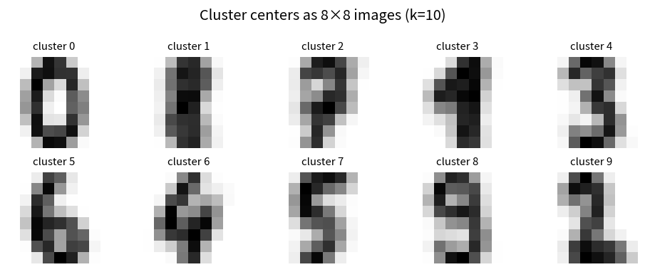
Figure. Ten centroids as 8×8 prototypes — the pictures a technician should see.

Key Takeaways
- K-means is unsupervised: fit(X) never sees y. Purity is a post-hoc name for each bin.
- Inertia always falls with k; the elbow on digits is soft. Ten is a story, not a proof.
- A centroid is an image. If two digits look alike as averages, they will share a cluster.
- fit before predict. n_init>1 fights a bad random start. Mini-batch is close (purity 0.787).
- Same pipeline segments customers, quantizes colors, or prototypes sensor snapshots — not a CNN replacement for modern mail volume.

